Clarivate Assessment

1. Created 3 component.

Element-list:

List of all data in table format (id, title, image and checkbox to add element to favorites list)

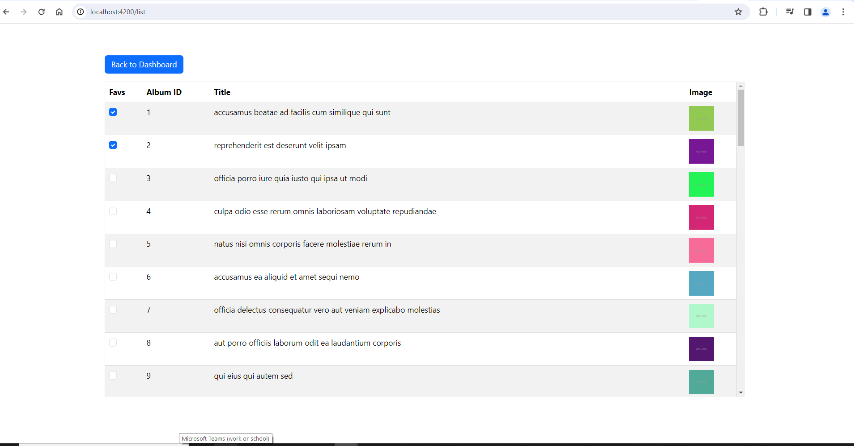Button to go back to dashboard page.

Dashboard:

List of favorites data in table format, which got added to favorites list in element-component.

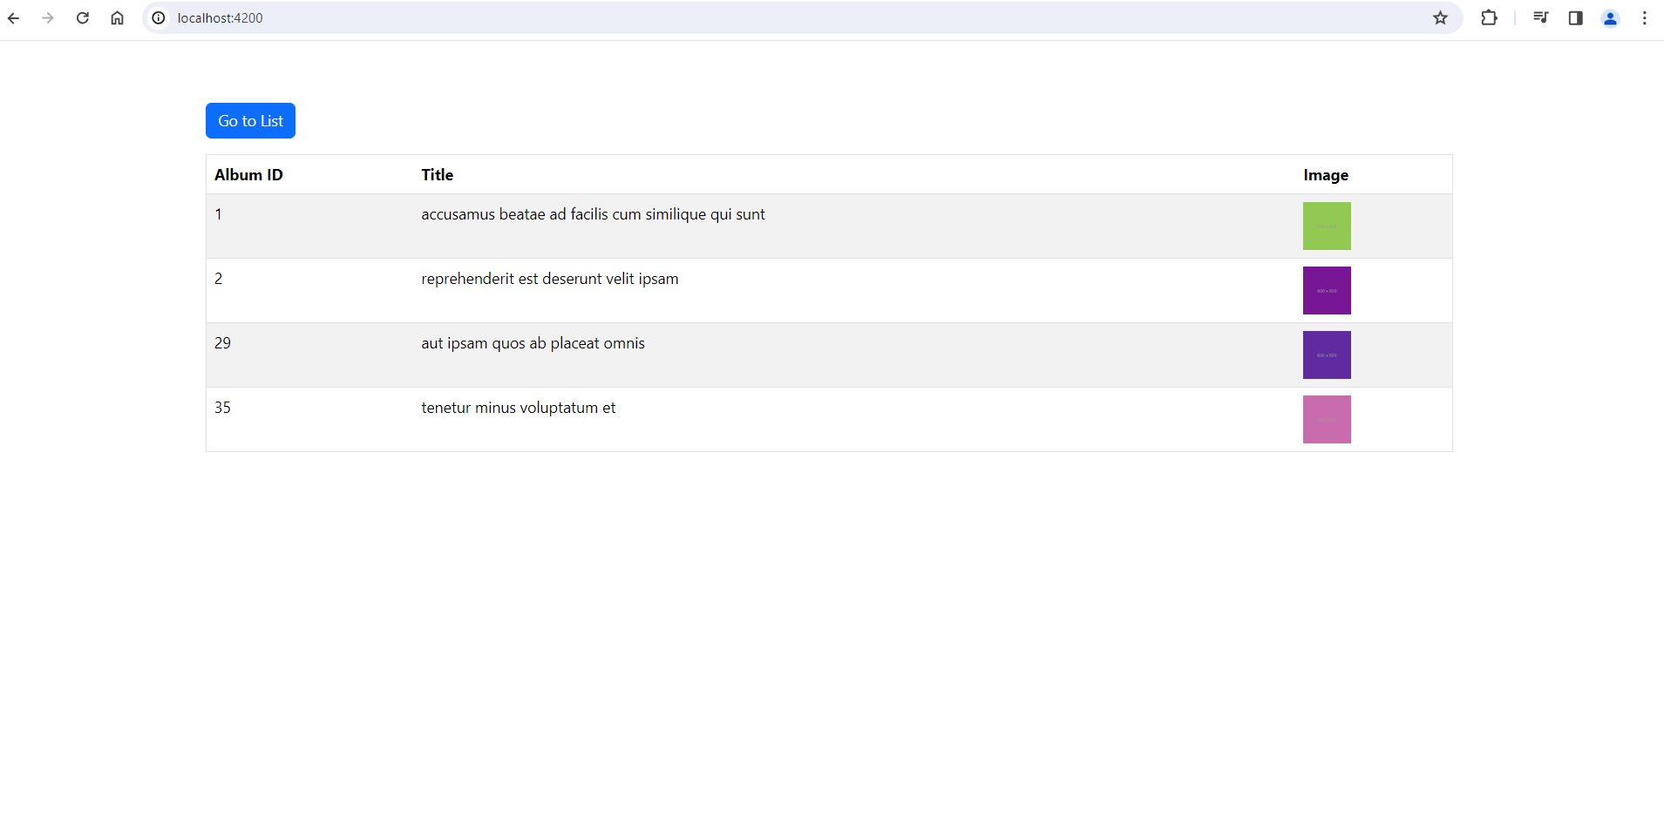Button to go to list page

Not found:

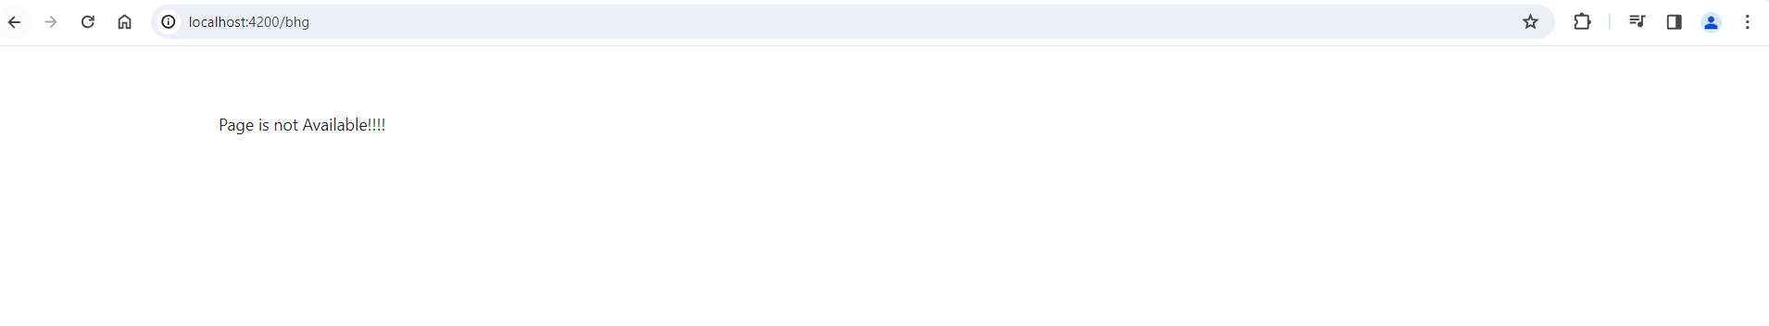 If some url path user trying to reach is not reachable. It will display “Not found”.

1. Path has been added in routing file for different component:

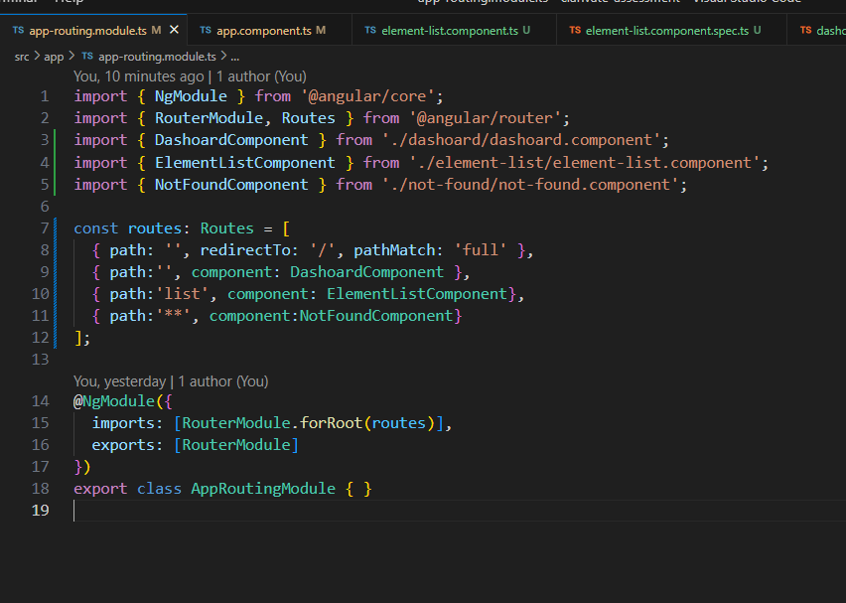

1. Scroll handler has been added on every scroll call is going to Api and fetching 10 elements and loading parallel in UI.
2. Local storage has been to use to fetch the retain data.
3. To have multiple API call, forkjoin has been used.
4. Bootstrap classes being used for styling.